# BENGBENG - race form

Write a program to integrate all the main functions of BENGBENG. Similar to the programming thinking in Lesson 6, OLED displays the function menu, button selects a function, and switch a function. Realize a program that can play all the functions.

## Install BENGBENG - race form

|  |  |
| --- | --- |
| SSJY2-01 套件 蹦蹦 赛车形态_空白视图 2_51 | SSJY2-01 套件 蹦蹦 赛车形态_空白视图 2_52 |
| SSJY2-01 套件 蹦蹦 赛车形态_空白视图 2_53 | SSJY2-01 套件 蹦蹦 赛车形态_空白视图 2_54 |
| SSJY2-01 套件 蹦蹦 赛车形态_空白视图 2_55 | SSJY2-01 套件 蹦蹦 赛车形态_空白视图 2_56 |
| SSJY2-01 套件 蹦蹦 赛车形态_空白视图 2_57 | SSJY2-01 套件 蹦蹦 赛车形态_空白视图 2_58 |
| SSJY2-01 套件 蹦蹦 赛车形态_空白视图 2_59 | SSJY2-01 套件 蹦蹦 赛车形态_空白视图 2_60 |
| SSJY2-01 套件 蹦蹦 赛车形态_空白视图 2_61 | SSJY2-01 套件 蹦蹦 赛车形态_空白视图 2_62 |
| SSJY2-01 套件 蹦蹦 赛车形态_空白视图 2_63 | SSJY2-01 套件 蹦蹦 赛车形态_空白视图 2_64 |
| SSJY2-01 套件 蹦蹦 赛车形态_空白视图 2_65 | SSJY2-01 套件 蹦蹦 赛车形态_空白视图 2_66 |
| SSJY2-01 套件 蹦蹦 赛车形态_空白视图 2_67 | SSJY2-01 套件 蹦蹦 赛车形态_空白视图 2_68 |
| SSJY2-01 套件 蹦蹦 赛车形态_空白视图 2_69 | SSJY2-01 套件 蹦蹦 赛车形态_空白视图 2_70 |
| SSJY2-01 套件 蹦蹦 赛车形态_空白视图 2_71 |  |
|  | |

### **Multi-function vehicle**

**（1）Program idea**

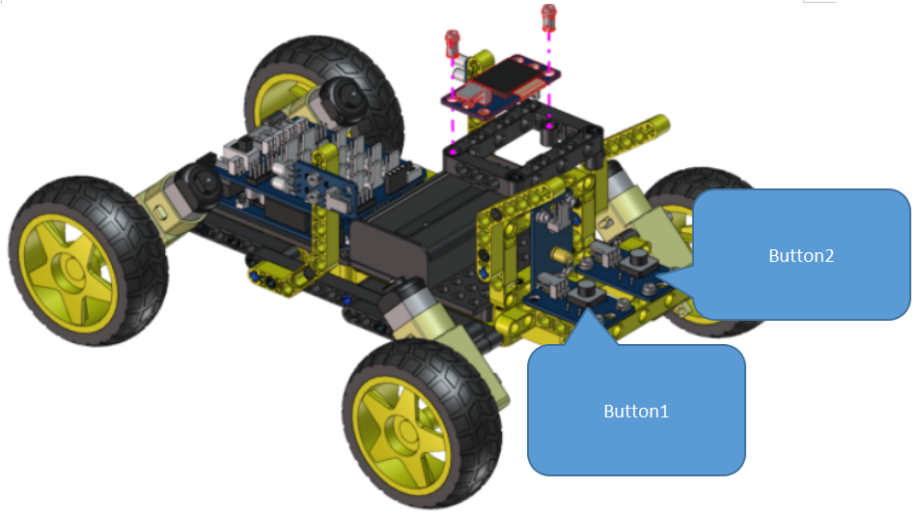

OLED screen displays function menu

Click button 2 to select a function

Long press button 2 to enter the selected function

Click button 1 to execute the function

Press and hold button 2 to exit the function

1. **Example program**

The example program is large, please open the program to view as below.

|  |
| --- |
|  |

1. Experiment operation and phenomenon

OLED screen displays function menu

Click button 2 to select a function

Long press button 2 to enter the selected function

Click button 1 to execute the function

Press and hold button 2 to exit the function

Start menu

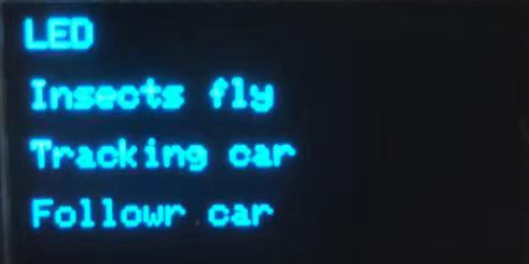

Function operation and phenomenon:

|  |  |  |
| --- | --- | --- |
| Click button 2 to select a function | Long press button 2 to enter the selected function | Operation and phenomenon |
|  |  | Click button 1 to turn on and off the LED. Long press button 2 to exit the function. |
|  |  | Click button 1 to play “Worms fly”, and long press button 2 to exit. |
|  |  | Click button 1 to open the tracking function, and long press button 2 to exit. |
|  |  | Click button 1 to open the following function, and long press button 2 to exit. |
|  |  | Click button 1 to open the obstacle avoidance function, and long press button 2 to exit. |